Steps to connect to Web/App/DB/CCG Windows Servers - SOP

1 AWS Infrastructure Resources 2

1.1 Port Forwarding Steps from RHEL Bastion EC2 to Web/App/DB/CCG Windows Servers 2

# AWS Infrastructure Resources

## Port Forwarding Steps from RHEL Bastion EC2 to Web/App/DB/CCG Windows Servers

Step1:

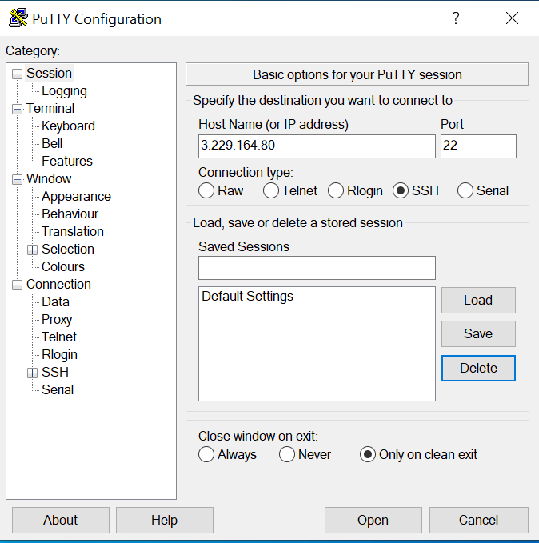Launch Putty and enter the Bastion server EIP Address in the Host name (or IP address) field.

Step2:

Under the Connection menu, expand SSH and select Tunnels. Check the Local radio button to setup local port forwarding.

When setting up local forwarding, enter the local forwarding port,(ex:50001)in the Source Port field and in Destination enter the destination IP with RDP Port, for example, “10.10.2.11:3389”

Click on the Add button, as shown in the image below

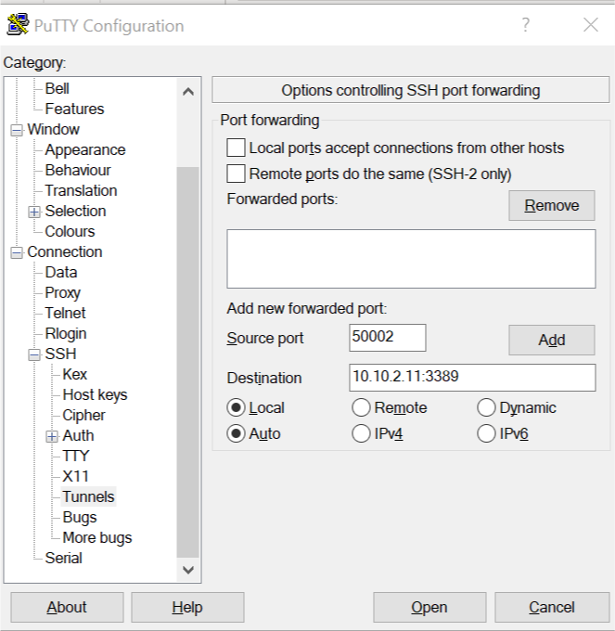

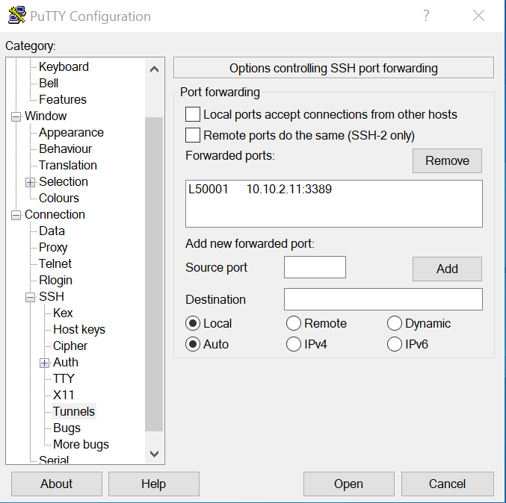

Step3:

Go back to the Session page to save the settings so that you do not need to enter them each time. Enter the session name in the Saved Session field and click on the Save button.

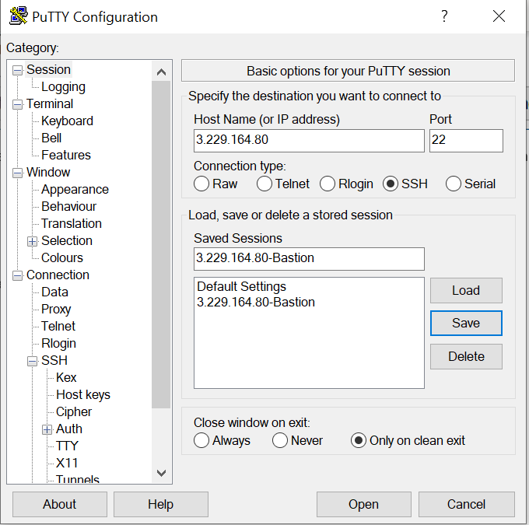

Select the saved session and click on load to use the saved session and click on open.

Step4:

A new window asking for your username and password will show up. Once you enter your username and password for Bastion EC2, you will be logged in to your Bastion server, and the SSH tunnel will be started.

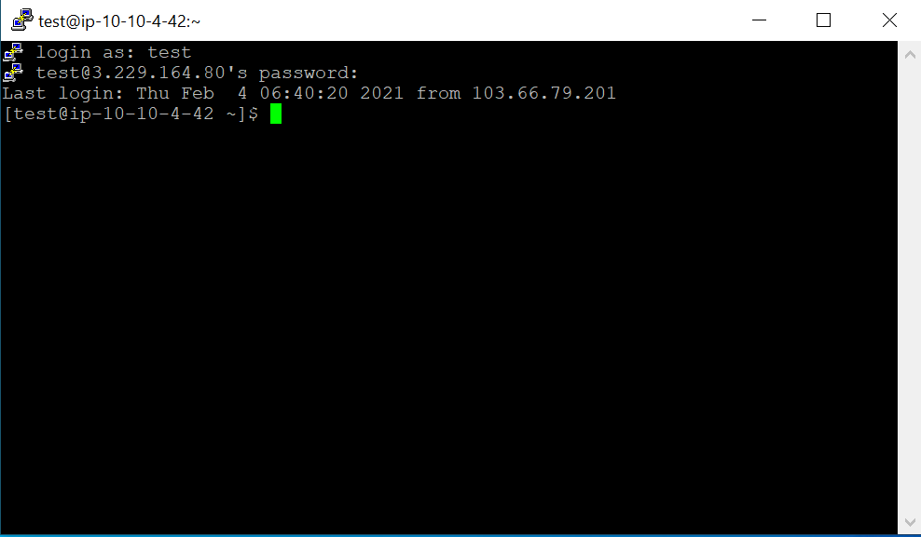

Step5:

Without closing the SSH Session open RDP client in your machine and type “localhost:<custom port>”.

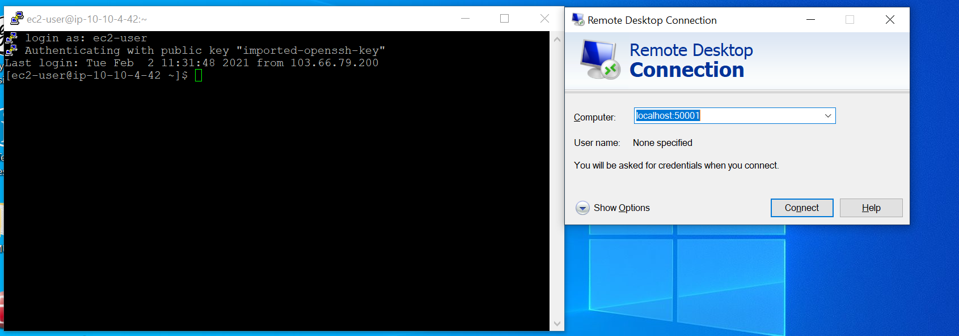

Step6:

Login to the Web/App/DB/CCG windows servers with your Username and Password.

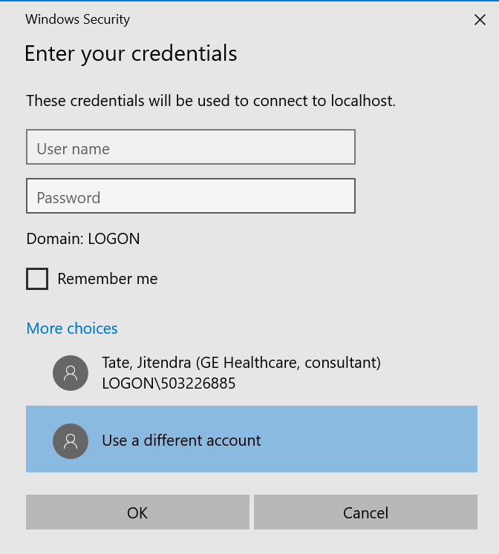

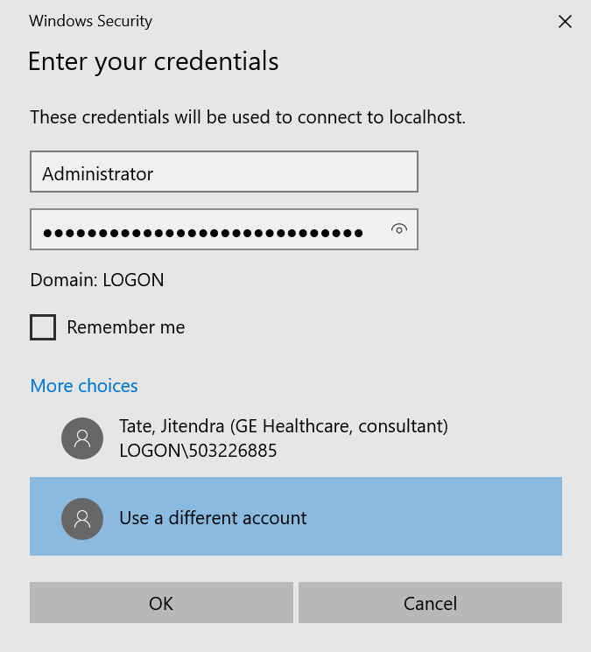

Now you can get connected to the windows server